Exp 4

Create a Snapshot of a VM and Test it by loading the Previous Version/Cloned VM

1. Click on create a new virtual machine

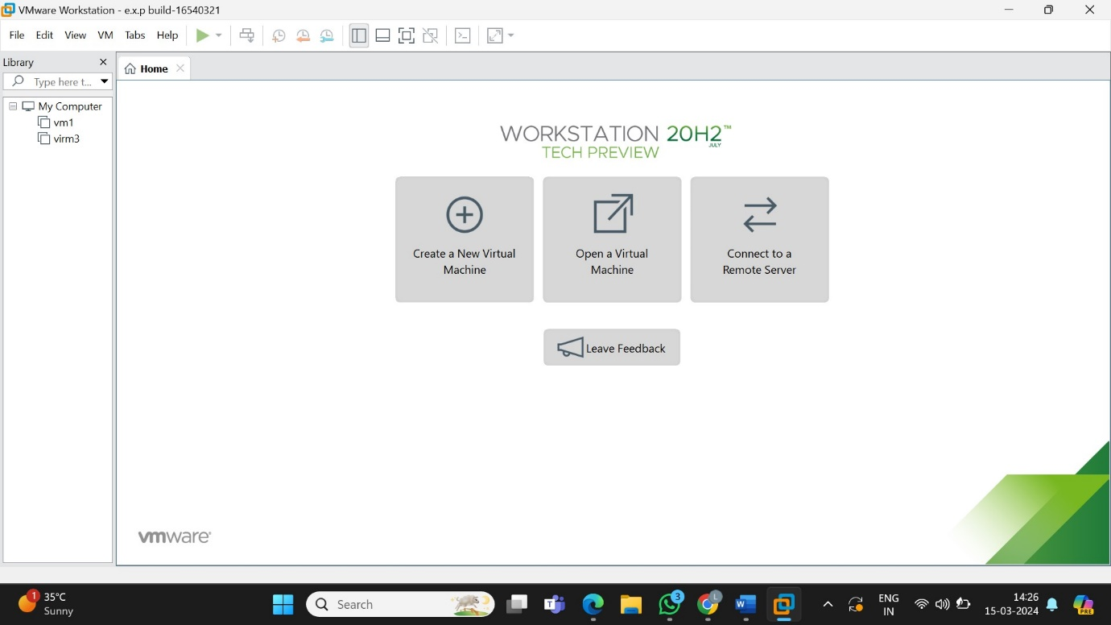

2.select the configuration as typical

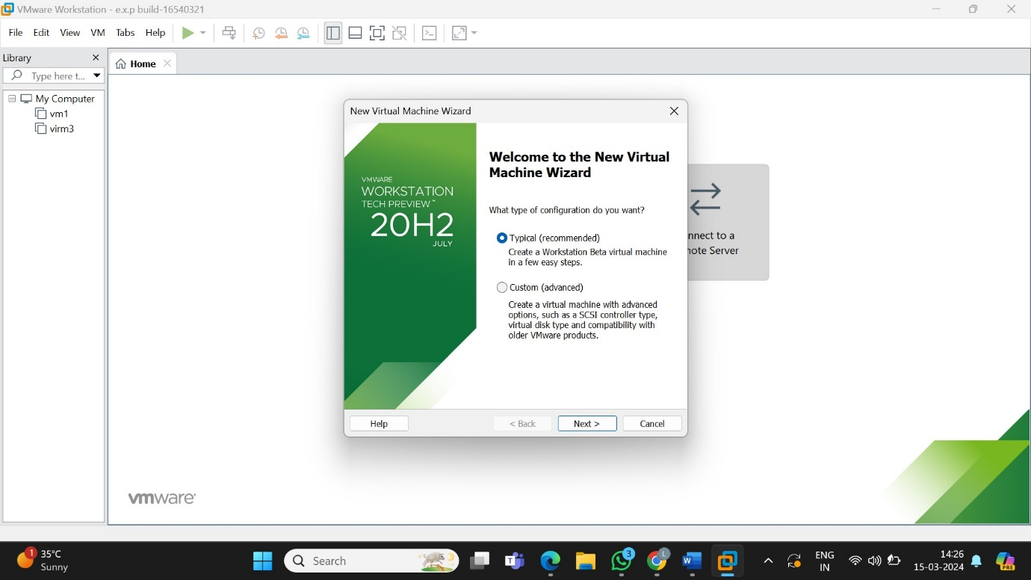

3.select the guest OS installer

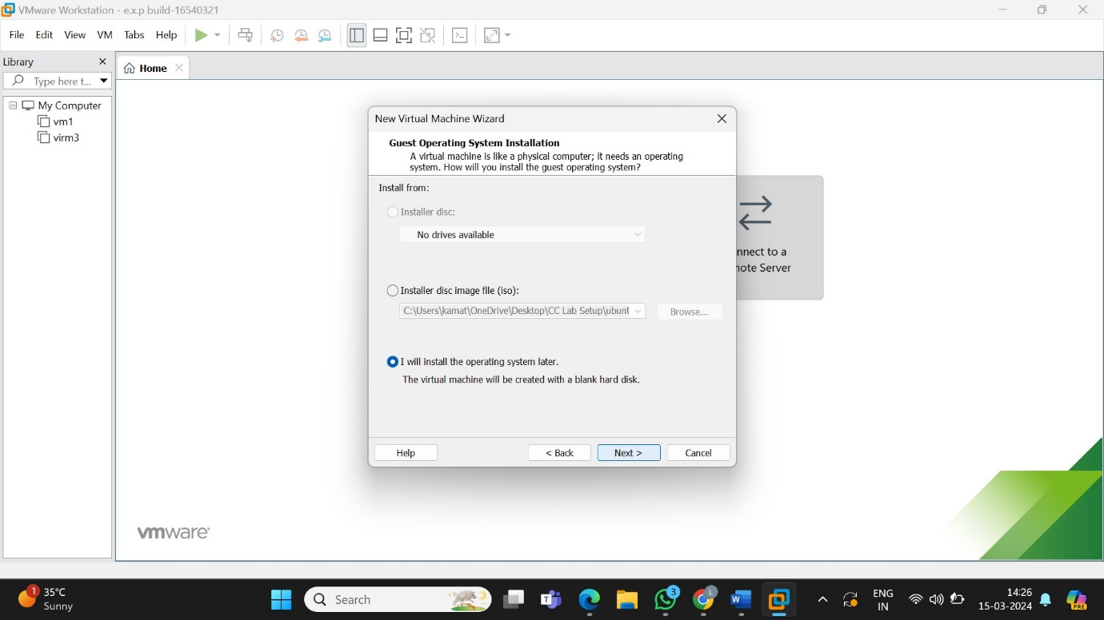

4.select the guest operating system

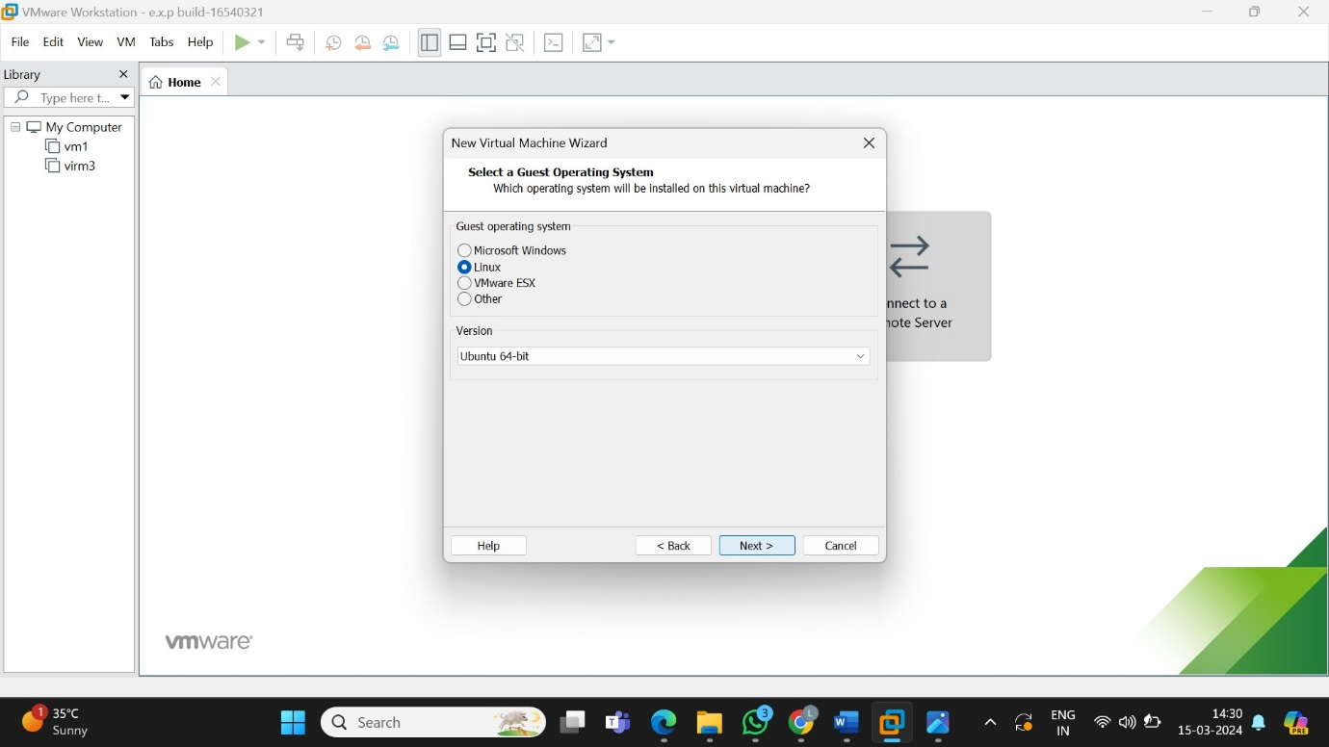

5.name the virtual machine

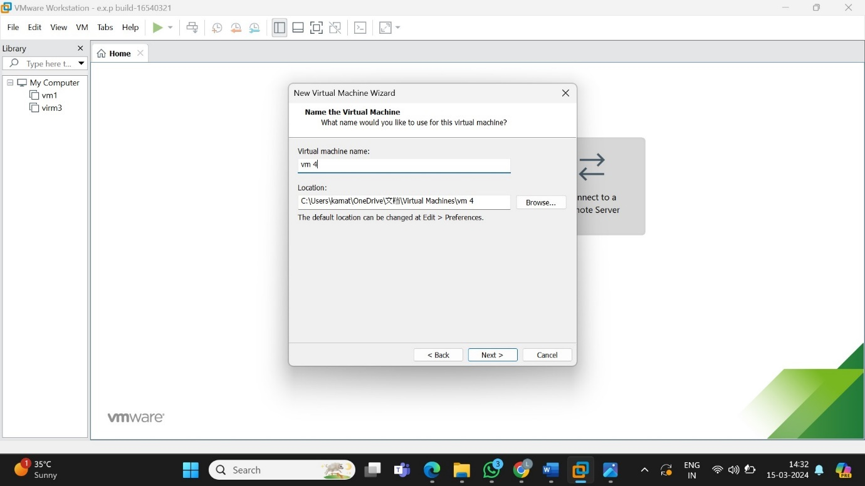

6.specify the disk capacity as store in single file

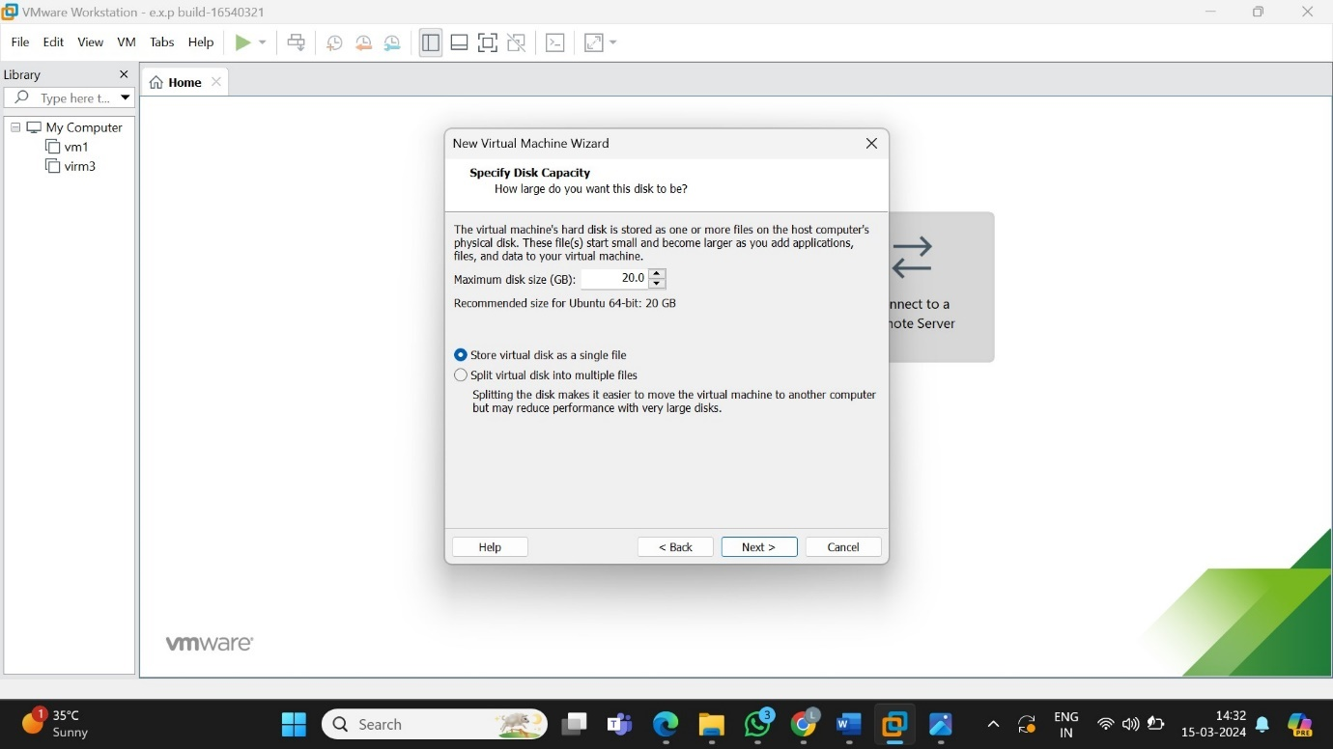

7.shows the description

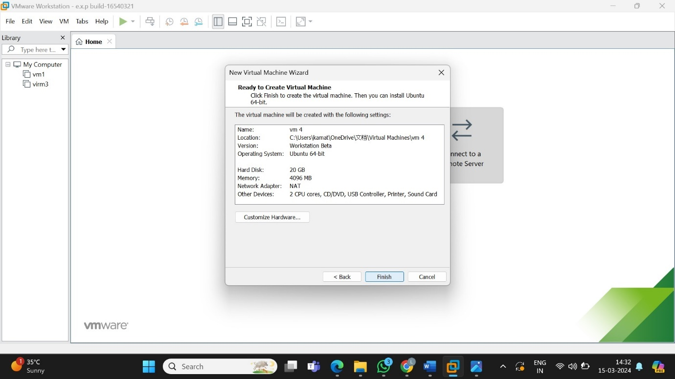

8.shows the virtual machine

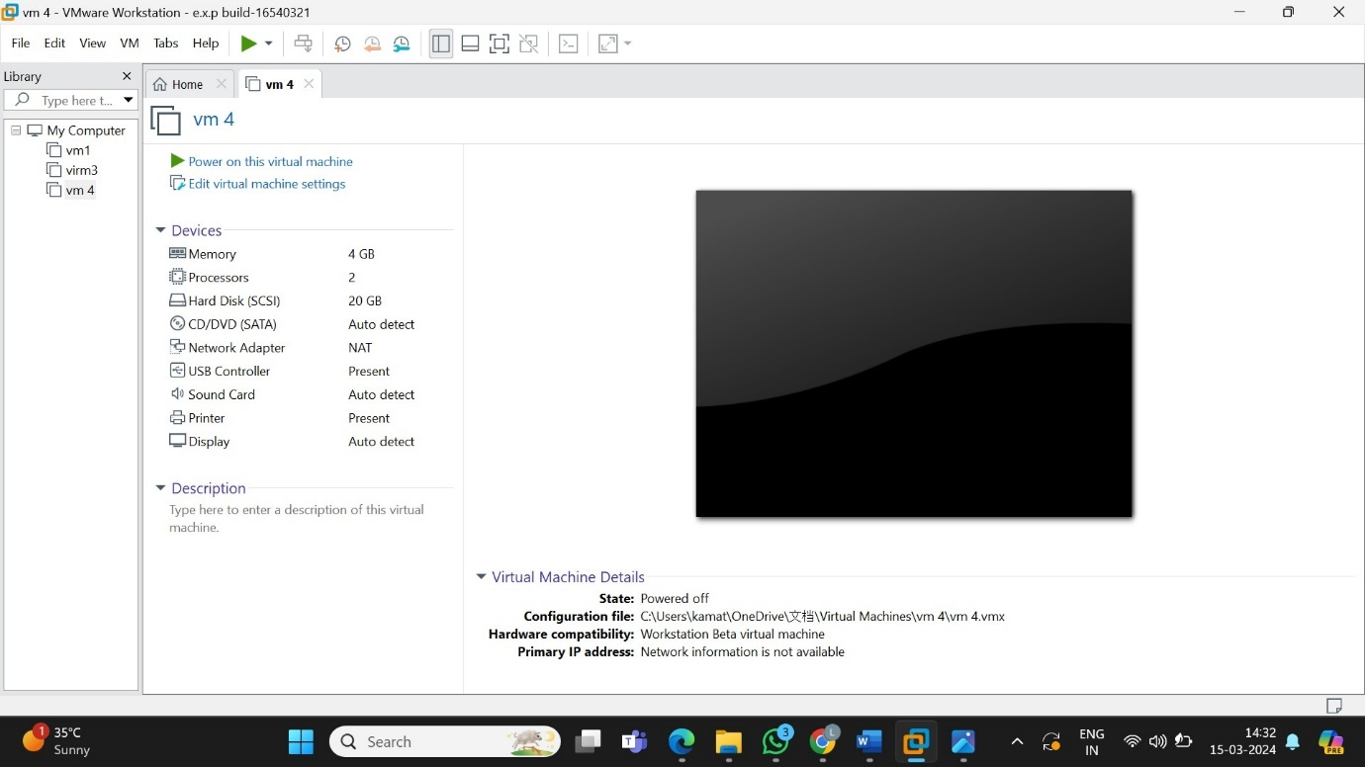

9.go to vm and choose snapshort then click on take snapshort

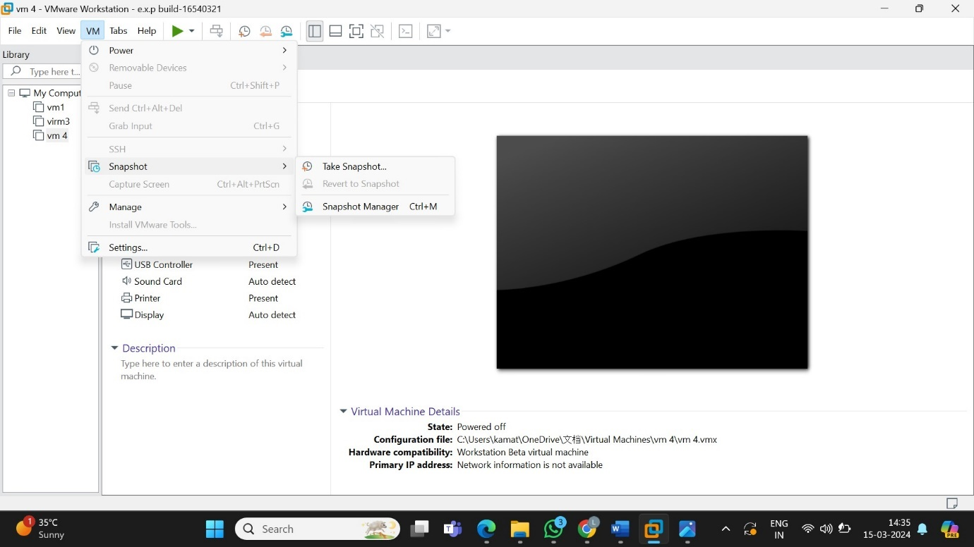

10.take another screenshot

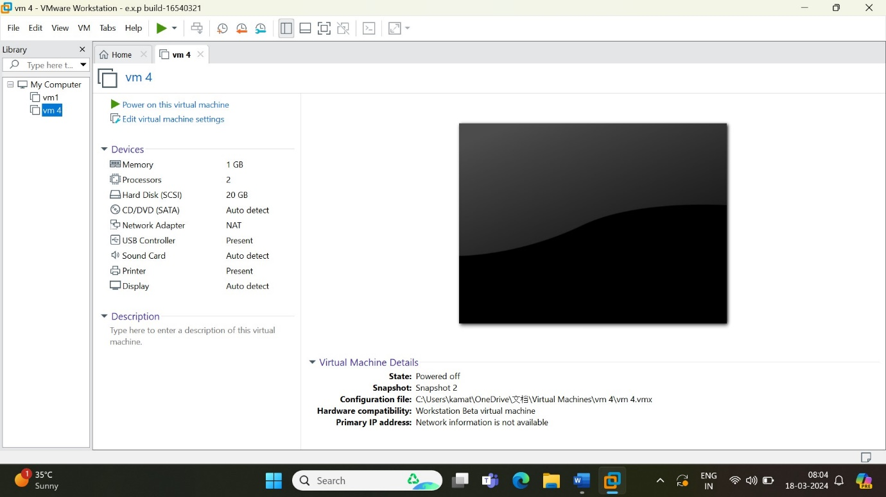

11.go to vm select manage then go to clone then create the clone version of the existing one

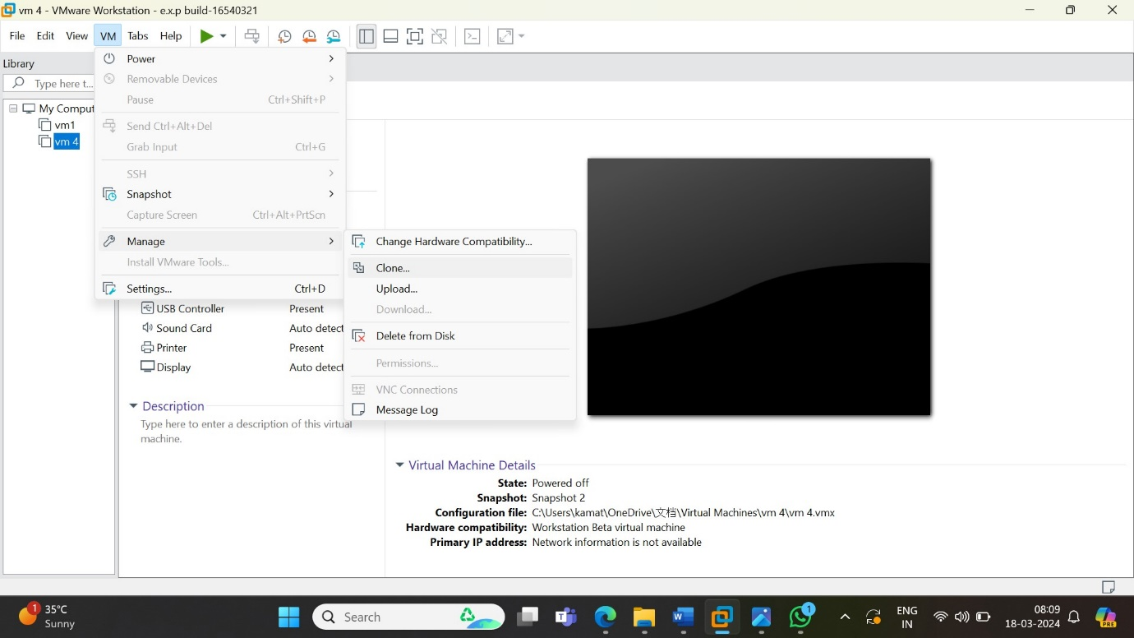

12.cloned version of the screenshot two

